EARTH 331
FIELD PROBLEMS IN SEDIMENTARY GEOLOGY

Fall Quarter

Instructors: Brad Sageman __________________
TECHF397, 467-2257 __________________
brad@earth.northwestern.edu __________________

Fieldtrip: late AUG to mid SEPT in CO and UT

Lecture: 3:30-5:00 T-TH

Reading
Compton, R., 1985, Manual of Field Geology, Wiley & Sons, NY, 378 pp.
Chap 1-5, 11, and 16 (Chaps. 9-10 optional).

Articles from the literature on the stratigraphic units examined in the field

Evaluation
•Fieldwork (20%)
•Report on field work (80%)

INTRODUCTION
This course focuses on field-based application of the basic information and fundamental concepts that were introduced in EARTH 330 – Sedimentary Geology. The course assumes that students have had little or no experience in the field and it is designed to teach the basic practices of field stratigraphy and sedimentology. In addition, because the development of process sedimentology, facies models, and sequence stratigraphy have come to dominate the fields of stratigraphy and sedimentology in recent years, this course is aimed at strengthening knowledge of these areas. In addition to discussions on the outcrops, we will have the opportunity during the Fall Quarter to explore topics that are relevant to the units we study in the field, by comparing our own observations, as well as reading the literature.
Field courses require unconventional efforts – review of prior course work before the start of the field trip will significantly improve your ability to function on the outcrop. Then there will be long days working under challenging conditions, eating, camping, and being together with a group for 24 hours a day, over three weeks. Although this may be richly compensated by the benefits of a hands-on learning experience, it requires patience and understanding from all.
The field trip leaders have a responsibility to make sure the trip runs safely and smoothly, and this requires significant logistical effort. You can help by being considerate, by thinking first about the goals of the trip before your own interests, and by asking how you can assist us. One critical rule of thumb….NEVER MAKE THE FIELD TRIP WAIT FOR YOU. This applies to highway meal stops and outcrops alike. When the leaders of the trip are ready to move, you should be on board and ready to roll.

Goals of the course:
A) Understanding the scientific method as applied in sedimentary geology
practical side of hypothesis testing
nature of geological knowledge

B) Understanding sedimentary geology
fundamental principals (facies, uniformitarianism, sedimentation, etc.)
data collection methods (observation, description, measurement, sampling)
sub-disciplines (stratigraphy, sedimentology, paleontology, structural geology)
facies models (as working hypotheses = interpreting depo environments)
sequence stratigraphy and process sedimentology
cyclostratigraphy and event stratigraphy

C) Understanding geologic history of Colorado and Utah (Penn. to Cret.)

There are four major phases of the course, as described below.

Course outline

a) Lecture (1 day): After arrival in Colorado, there will be a day of lecture to review concepts (stratigraphic principles, depositional systems-facies models, sequence stratigraphy, and field methods) and provide instructions for the format of field notebooks and field exercises.

b) Field trip/field exercises (approx. 18 days of field work): A series of specific field exercises will be performed at sites from Boulder, Colorado to central Utah. Students will record measurements and observations in field notebooks. See Itinerary below for sites and exercises (in boldface).

c) Fall quarter meetings: After returning from the field we will meet as a class during the Fall Quarter. The main purpose of our meetings is to assist you in the construction of your field report. We may discuss research papers that are relevant to the stratigraphic units we have seen in the field, and which explore pertinent aspects of facies analysis and sequence stratigraphy. We will also work on specific skills related to presentation of field data (drafting sections, presenting observational data).

d) Final Project: The field report will be due at the end of the quarter (NOV. 30). The report will focus on observations from the field exercises, but you may incorporate information from the literature as well.

Preliminary Reading List
Review material
Chapters on depositional environments from Nichols (or Boggs) and the Facies Models books.

New material
Compton, R., 1985, Manual of Field Geology, Wiley & Sons, NY, 378 pp.
Chap 1-5, 11, and 16 (Chaps. 9-10 optional as they likely repeat above review material) .

Additional reading materials pertaining to the regional geology of our field areas will be available on the trip and thereafter.

Expectations
Students should review facies models and complete the Compton reading before the course starts in Boulder. Bear in mind that reading will not be impossible, but it is more challenging to make progress once the field work starts.

A note on the nature of field work – because there is only a limited opportunity to make observations, field geologists endeavor to maximize the experience. This can mean long days, working in less than optimal weather, etc. But these hardships are more than compensated by the beauty of the places we visit, the amazing geology we see, and our irrepressibly positive attitudes.

Do not be afraid to ask questions. Do not be afraid to call for help in the field. Do not be afraid to ask us to SLOW DOWN. This experience is for you – we want you to learn as much as possible and to enjoy the field as much as we do. But those of us who do field work can tend to move quickly when we are on the outcrops.

Evaluation of performance in the class will be based on the following criteria:
1) knowledge of the reading material and participation in the lecture phase
2) field notebook - format and style, neatness and legibility (see Compton for guidance)
3) field exercises – participation and application of knowledge on the outcrop
4) final report - completeness, presentation style, integrity with field notes

2016 EXAMPLE ITINERARY

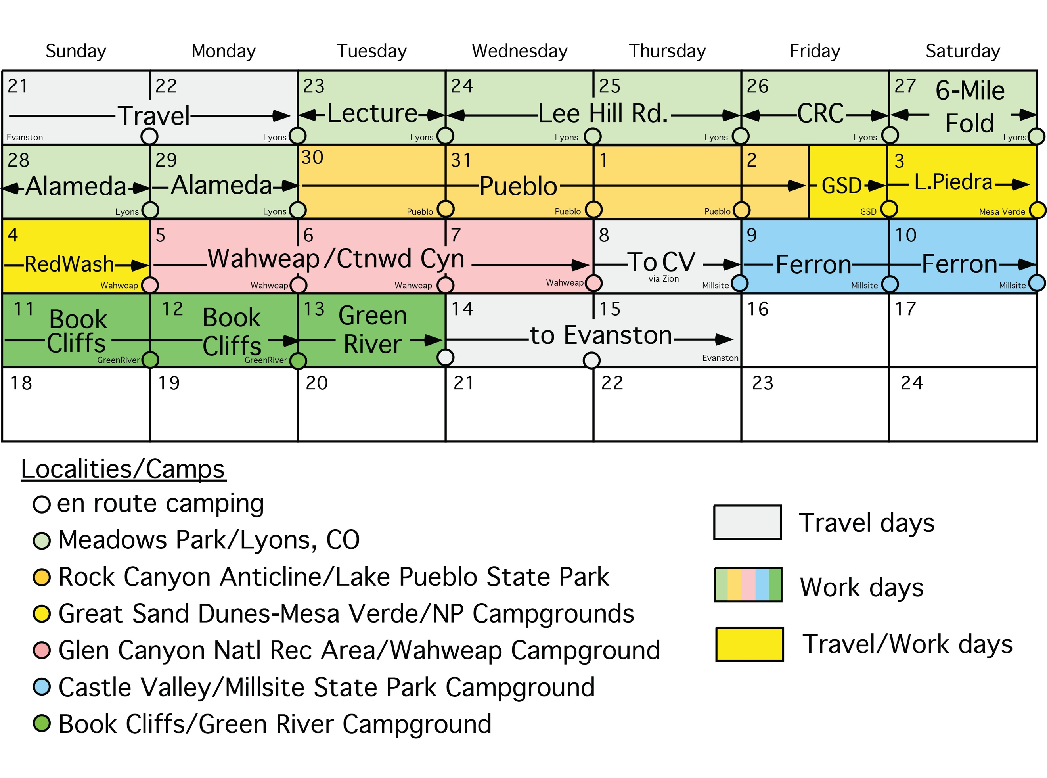

Itinerary specifics on following page…

Vans will leave Evanston on SUNDAY August 21.

• TUES 8/23 - LECTURE
DEPT. OF GEOLOGICAL SCIENCES, UNIVERSITY OF COLORADO

• WED 8/24 through MON 8/29 – Boulder-Denver Field Work Area
Lee Hill Rd. sections –
Fountain Fm. (Pennsylvanian) through Lyons SS (Permian)
Lyons SS to base Dakota Group (Cretaceous)
Dakota Group (K_{d}) section
Core Description exercise USGS-CRC) – Dakota Formation
6-Mile Fold - Mapping Cretaceous folded strata (Carlile and Niobrara Fm.s)
Alameda Roadcut - top Morrison Fm. (Jurassic) thru Dakota Group (Kd)

• TUES 8/30 through FRI 9/2 – Pueblo State Park Field Work Area
Drive to Pueblo - Camp at Lake Pueblo State Park
Rock Canyon Anticline
Greenhorn & Niobrara Cyclothems (Cretaceous)
Dakota Sandstone, Graneros Shale, Greenhorn Formation, Carlile Formation
Niobrara Formation (Ft. Hays LS)

• FRI 9/2 - Drive to Great Sand Dunes Natl. Monument
observe/discuss modern eolian processes

• SAT 9/3 - Drive to Mesa Verde National Park (MVNP)
visit Lower Piedra section: Mancos Shale (Cretaceous)
camp at MVNP

• SUN 9/4 – Drive to Page, AZ and Wahweap Campground
visit roadcuts in MVNP - Mesa Verde Fm. (Cretaceous)
visit Red Wash Section - Dakota SS and Mancos Shale (Cretaceous)

• MON 9/5 through WED 9/7 – Dakota Formation field work
Wahweap Wash & Cottonwood Canyon exercise
Dakota SS and Tropic SH (Cretaceous)

• THURS 9/8 – Drive through with stops, Zion National Park
Jurassic eolian facies and climate cycles preserved in cross bedding

• THURS 9/8 through SUN 9/11 - Castle Valley & San Rafael Swell, UT
Castle Valley Field Work Area
Ferron SS (Cretaceous) – fluvial-deltaic facies
Ferron State Park Campground

• SUN 9/11 through TUES 9/13 – Book Cliffs, UT and Green River Fm., CO
Book Cliffs Field Work Area
Castlegate and Starpoint Sandstones (Cretaceous)
Greenriver Fm.
Green River State Park Campground

• THURS 9/14 – Home to Evanston.

EARTH 331 EQUIPMENT LIST

Equipment/clothing
Bring old clothes suitable for outdoor activity (they will get muddy, dirty, etc.). Be prepared for cold and snow, rain at any temperature above freezing, and oppressively sunny and hot (but relatively dry, in general) weather. Bring several changes of clothes so that you always have a dry pair in the event of rain. Specifically, we recommend:

CLOTHES
• Hiking boots, preferably waterproof • Sun hat, sunglasses
(plus dry pair of shoes for evening) • Hiking shorts, T-shirts, etc.
• Waterproof jacket (essential) • Lots of socks (no kidding)
• Warm sweater, sweat shirt, or jacket • Warm socks, gloves & hat

CAMPING/HIKING GEAR
• Water containers – CAMELBACK or similar advised. • A sleeping pad (e.g., Thermarest)
AT LEAST 2.5 QUARTS/PERSON/DAY • Tent (we will work out sharing)
• A daypack to carry everything you're not wearing • Flashlight and batteries
• A sleeping bag (for summer/fall camping - a cotton liner/sheet is good for hot weather)
• Toiletries - soap/shampoo/toothbrush/sunscreen/medicines (e.g.,analgesics)/bug spray etc.

WORK EQUIPMENT
You should get:
• Work Gloves
• Pens, pencils, eraser (plastic cover if not write-in-the-rain)
• Clipboard (is always helpful for notes/handouts/maps)
• Camera (a key item for geological field work)

We can provide:
• Bruntons • Hammer /belt loop • Hand lens
• Jake staffs • Tape measures • Acid bottles • Field Notebooks

CONTACT LENS WEARERS – we strongly recommend that you bring glasses as there will be times that contacts may not be wearable due to wind/dust.

Medical Conditions
Be sure to inform us if you have any condition or physical disability that could require special attention in the field, or if you are taking any prescriptions with potentially adverse side effects (remember - dehydration is a likely condition at some point during field work). Let us know IMMEDIATELY if are injured in the field. We will have cell phones for emergencies and contact numbers for medical assistance in the areas we are visiting. Lastly, as a precaution, each student should give us a family telephone # to call in the event of an emergency. Have this ready when we meet for class on 8/25.
PART I - 8/24 - 9:00 am, Dept. of Geological Sciences, University of
Colorado: Introductory lecture and discussion

LECTURE OUTLINE AND BACKGROUND MATERIAL

A) Review of Basics – Stratigraphy and Sedimentology
Lithologic description – texture and composition
Lithologic classification – arenites, mudrocks, carbonates
Additional observations: bedding, contacts, sedimentary structures,
biogenic structures, fossils, etc.
Strike and dip: Brunton compass; trig methods
Section thickness: Jacob staff/measuring tape

Goal: Develop methodology and criteria for measurement and
description of stratigraphic sections.

B) Review of Facies Models (Walker and James, 1992)
Chap. 1 - Facies, facies models and modern stratigraphic concepts
Chap. 7 - Alluvial deposits
Chap. 8 - Eolian systems
Chap. 9 - Deltas
Chap. 10 - Transgressive barrier island and estuarine systems
Chap. 12 - Wave and storm dominated shallow marine systems
Chap. 14 - Intro to carbonate and evaporite facies models

Goal: Develop working facies models for selected facies types.

C) Overview of Sequence Stratigraphy and Dynamic Sedimentology
Walker and James (1992): Chap. 2 - Control of sea level change
Boggs (1995), sections on sequence stratigraphy
This Coursebook - Sequence Stratigraphy/Dynamic Sedimentology

Goals: Review sequence stratigraphic concepts and nomenclature
Introduce concepts of dynamic sedimentology (energy profiles)
Integrate stratigraphy and dynamic sedimentology = genetic
sequence stratigraphy.

D) Overview of Manual of Field Geology (Compton, 1985)
Essential reading
Chap. 1 - Introduction Chap. 4 - Identifying rocks in field
Chap. 2 - Basic equipment Chap. 9 - Primary features marine sed rx
Chap. 3 - Basic outcrop procedures Chap. 11 - Stratigraphic sections

Supplemental reading
Chap. 5 - Mapping rocks and structures Chap. 16 - Preparing reports
Goals: Review principles and field methods for sedimentary geology
(scientific method; techniques for observation, data collection and presentation)
Develop protocols for field notes, lithologic descriptions, etc.

